Borderlands Mexico: Uber Freight sees earlier peak season, strong Mexico demand

Noi Mahoney, Sunday, June 07, 2026
Original Article: https://www.freightwaves.com/news/borderlands-mexico-uber-freight-sees-earlier-peak-season-strong-mexico-demand
Articles Reproduced by Permission of FreightWaves

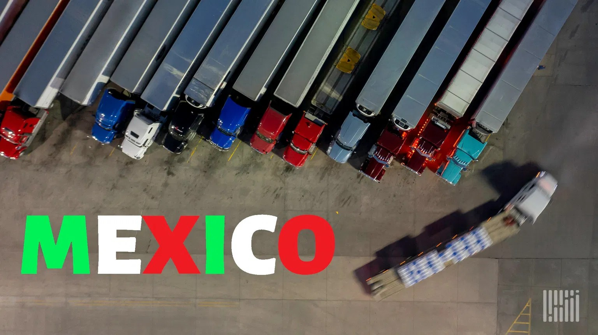
Uber Freight's latest market outlook suggests shippers relying on U.S.-Mexico supply chains face a significantly tighter freight market through the second half of 2026. (Photo: Jim Allen/FreightWaves)

Borderlands Mexico is a weekly rundown of developments in the world of United States-Mexico cross-border trucking and trade. This week in Borderlands Mexico: Uber Freight sees earlier peak season, stronger Mexico demand; Mexico freight trucking sector outpaces broader economy in Q1; and 1.1M-square-foot logistics center planned in Phoenix area.

Uber Freight sees earlier peak season, stronger Mexico demand
Uber Freight says U.S.-Mexico freight markets are tightening faster than expected as strong produce exports, rising fuel costs and declining driver availability push cross-border transportation rates higher heading into the summer shipping season.

The findings were included in Uber Freight’s Q2 Market Update & Outlook report released Thursday, which concluded that several market pressures expected later in 2026 are already impacting freight networks across North America.

The report forecasts truckload spot rates will remain 20% to 25% above 2025 levels for the remainder of the year, while contract rates could rise 5% to 10%.

“Peak season appears to be arriving earlier and behaving differently than normal,” Uber Freight said, citing a combination of produce volumes, fuel costs and tightening capacity.

Mexico produce exports drive demand
One of the strongest themes in the report is the impact of Mexico’s agricultural exports on cross-border freight markets.

Uber Freight said produce volumes moving through Laredo are experiencing one of the heaviest seasons on record. March shipments of citrus, fruits and nuts from Mexico were up more than 36% compared to the same period in 2025, while total exports moving through Laredo increased 8% year over year.

The surge in agricultural freight has helped pull trucking capacity toward key cross-border corridors and produce-growing regions.

According to the report, carriers have increasingly shifted equipment to take advantage of stronger reefer rates, creating capacity shortages for dry van shippers and contributing to broader market tightening.

Uber Freight noted that Fresno-to-Chicago reefer spot rates jumped 43% in a single month, while produce transportation rates from California to Chicago increased nearly 25% in recent weeks.

The company advised shippers to tender freight four to five days in advance on cross-border lanes and secure reefer capacity early before summer demand peaks.

Cross-border rates climb
Uber Freight said freight rates between Mexico and the U.S. have risen sharply since February.

The report’s Mexico outlook found cross-border rates are up 8% to 15% across the market, while some major corridors have seen increases approaching 30% in just two months. Fuel inflation, produce demand and driver shortages are combining to create upward pressure on transportation costs.

The report also highlighted declining availability of B-1 commercial drivers, a trend that has become increasingly important for carriers serving cross-border freight markets. Uber Freight listed falling B-1 driver capacity among the primary factors tightening Mexico-U.S. freight networks.

Fuel prices add new pressure
At the same time, transportation providers are facing rapidly rising fuel costs.

Uber Freight reported the national average diesel price reached $5.64 per gallon in May, up from $3.72 per gallon in February. The increase was driven largely by geopolitical disruptions in the Middle East and reduced oil flows through the Strait of Hormuz.

The company noted that fuel surcharges are becoming a growing issue in cross-border transportation because many Mexico freight lanes do not have standardized fuel surcharge programs.

Shippers should review fuel surcharge agreements, shorten surcharge adjustment cycles and add fuel accessorials where necessary, Uber Freight said.

Capacity tightening across North America
Beyond cross-border markets, Uber Freight reported truckload conditions are tightening nationwide despite what is normally a softer seasonal period.

Van spot rates increased 24.8% year over year in April, reefer rates rose 26.3%, and flatbed spot rates climbed 23.7%. Meanwhile, spot market volumes were up 44% year over year. First-tender acceptance rates slipped to 82%, while route-guide compliance fell to 86%, forcing more freight into the higher-cost spot market.

Uber Freight said regulatory changes are also contributing to capacity constraints. The company estimates the Federal Motor Carrier Safety Administration’s non-domiciled CDL rule could remove roughly 40,000 drivers annually over the next five years, tightening available capacity even further.

Supply chains remain volatile
International freight markets continue to face uncertainty as geopolitical conflicts, tariff policy changes and shifting sourcing strategies alter global trade flows.

Uber Freight said global schedule reliability remains near 63%, while companies continue diversifying sourcing away from China and adjusting supply chains in response to changing trade policies.

For shippers, the message from Uber Freight is clear: conditions that many expected to emerge during peak season are already here.

“The window to get ahead of these conditions is narrowing,” the report said, urging shippers to secure capacity earlier, closely monitor tender acceptance rates and develop contingency plans for critical domestic and cross-border lanes.

Mexico freight trucking sector outpaces broader economy in Q1
Mexico’s freight trucking sector grew 1.8% in the first quarter of 2026, outpacing both the broader transportation sector and Mexico’s overall economy as cross-border and domestic cargo demand remained resilient.

According to data from Mexico’s National Institute of Statistics and Geography (INEGI), the transport, postal and warehousing sector expanded 0.4% during the quarter, while Mexico’s gross domestic product increased 0.4% annually, reported Mexico Business News.

Freight trucking accounted for 51.4% of the GDP generated by Mexico’s transport, postal and warehousing sector and represented 3.8% of national GDP during the quarter.

1.1M-square-foot logistics center planned in Phoenix area
Houston-based Lovett Industrial and Peakline Real Estate Funds have broken ground on North Park Logistics Center, a 1.14 million-square-foot Class A cross-dock industrial facility in Glendale, Arizona.

The project will be developed on nearly 56 acres in Metro Phoenix’s Southwest Valley, with direct access to Northern Parkway, Loop 303 and Interstate 10, according to a news release.

The speculative development is designed to serve large-scale distribution users and will feature 40-foot clear heights, 197 dock doors, 29 knockout panels and extensive trailer parking.

The first phase is scheduled for delivery in the second quarter of 2027, with a planned second phase adding approximately 623,000 square feet. The project is being marketed and leased by CBRE.

